

***Billy E. Johnson, PhD, PE, D.WRE, F.ASCE***

**Senior Scientist**

LimnoTech Inc.

501 Avis Drive

Ann Arbor, MI 48108

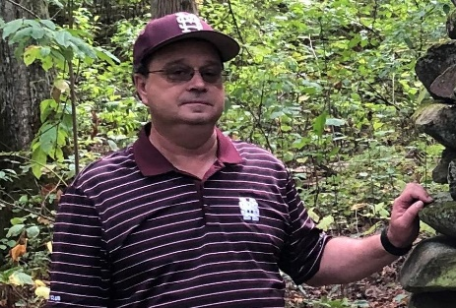Billy E. Johnson is a Senior Scientist at LimnoTech with broad expertise in water resources, including successful leadership of projects involving the development and application of sediment, nutrient, contaminant, and riparian vegetation simulation modules for civil works and military projects. These modules have been integrated with a variety of U.S. Army Corps of Engineers (USACE) hydraulic and hydrologic modeling systems. He has over 35 years of experience as a research civil engineer, educator, and consultant for projects across the U.S. In addition, he has been involved in developing a Physically Based Engineering With Nature (EWN) Design Tool, U.S. Army Installation Energy and Water Plans (IEWP), Flood Mapping and Mitigation Plans for Overseas DoD Installations in data-poor regions, and Low Impact Development (LID)/Nature-Based Features projects for DoD installations. Billy previously served as a senior researcher at the U.S. Army Engineer Research and Development Center (ERDC), Environmental Laboratory (EL). In addition to working for EL, he also worked for the ERDC Coastal and Hydraulics Laboratory (CHL), and the Memphis District USACE. He was an adjunct faculty member at Mississippi State University and served as an Associate Editor of the Journal for the American Water Resources Association (JAWRA). Billy currently resides and works in Vicksburg, Mississippi.

**Tel: 601-415-6299**

**E-mail(s):**

[**bjohnson@limno.com**](mailto:bjohnson@limno.com)

[**billy.e.johnson@usace.army.mil**](mailto:billy.e.johnson@usace.army.mil)